**A place at God’s table  
a liturgy for Holy Communion**

**invitation**

[sung]  
**Find your place around God’s table**

**Bread and wine – God’s gifts we share**

**As we eat and drink together**

**Jesus Christ is present here**

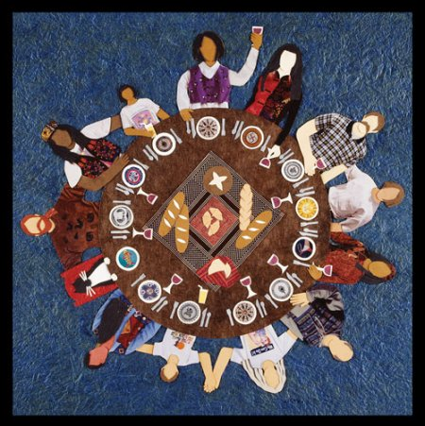Come - find your place around God’s table  
Come – for Christ here welcomes and heals,  
Here Christ refreshes, feeds and restores.  
Come – find your place around God’s table  
Christ invites you – whoever you are,   
whoever you are not, whoever you are yet to be.  
Saint or sinner – find your place here.

**Words of INSTITUTION**

On the night before Jesus died,  
on the evening of his betrayal,  
Jesus took bread, he took wine  
He gave thanks, saying, “Do this in memory of me”

[sung]

**Gather round, as we remember**

**Jesus taking wine and bread**

**‘My body, blood – it’s given for you’**

**Sacrament – as souls are fed.**

**Take your place around God’s Table**

**Taste and see that God is grace**

**Be encouraged, loved, forgiven  
Among God’s family, find your place.**  
 **THANKSGIVING**

God, we thank you and we praise you  
for you created this world, created us out of love

* a love without limits

In your great love you placed us, man and woman  
at the heart of your creation   
– calling us to tend it with compassion.

**Yet we failed to recognize our place in your creative dreaming  
We strayed from you, from our neighbour.  
So in time, despite the heartbreak of prophets  
you sent your own Son, Jesus Christ,   
to help us find again our place with you.**

So, we thank you for the life we know

in Jesus Christ, our Saviour  
We thank you for Christ’s faithfulness:

a faithfulness, true to his calling -

a faithfulness that took Christ all the way to the Cross  
  
**Dying on the Cross, he rescues us  
Rising from the died, he gives new life.**

**Faithful God, receive our sacrifice of praise.**  
Send to us the Holy Spirit  
that this meal may be a truly holy meal;  
that as we share bread and wine together  
we might experience a deep communion:

the sacramental presence of Christ,

that our souls will be fed,

that you will meet us in our thirst and our hunger,

that we will find our hope, our love and our life in you  
for in you we find our place – our reason for living.  
  
Christ is the bread of life  
Food for healing and wholeness  
  
Christ is the cup of hope  
Wellspring of resurrection life

**The gifts of God for the people of God.**

**THE COMMUNION/SERVING**

**AFFIRMATION AFTER COMMUNION**

[sung]

**We take our place around your table**

**We taste and see that you are grace**

**We go encouraged, loved, forgiven**

**Among God’s family, find our place**

*David MacGregor* © 2004 © 2019

**THE PEACE**The peace of the Lord be always with you.   
***And also with you.***