**I’ve got a voice**

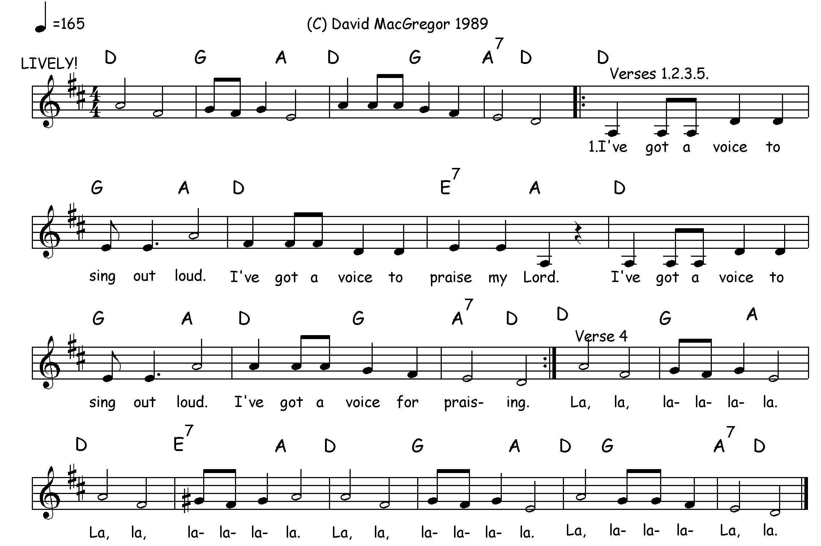

|  |  |  |
| --- | --- | --- |
| 1. I’ve got a voice to sing out loud  I’ve got a voice to praise my Lord  I’ve got a voice to sing out loud  I’ve got a voice for praising  2. I’ve got a hand to help someone  I’ve got a hand to praise my Lord  I’ve got a hand to help someone  I’ve got a hand for praising  3. I’ve got a heart to share God’s love  I’ve got a heart to praise my Lord  I’ve got a heart to share God’s love  I’ve got a heart for praising. | 4. La-la, la-la-la-la (3x)  La, la-la-la-la-la.  5. I’ve got a voice to sing out loud  I’ve got hand to help someone  I’ve got a heart to share God’s love  I’ve got a voice for praising.  *© David MacGregor 1989*     |  | | --- | | ***note***: verses 4 and 5 are to be sung together, with those singing subdivided into two groups; one singing 4, then 5. The other - 5, then 4.  Alternatively, in unison sing the verses solely in the printed order. | |