in God’s hands?

He’s got the whole world in his hands.

He’s got the whole world in his hands.

He’s got the whole world in his hands.

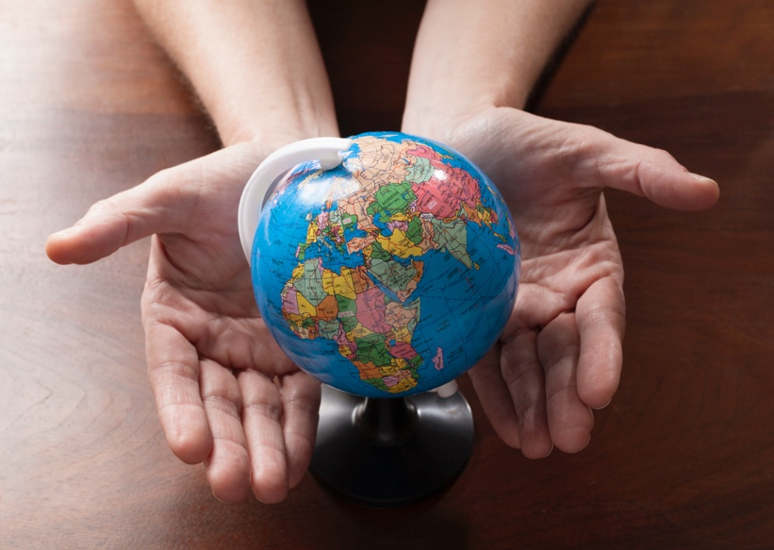He’s got the whole world in his hands.

Really?

Loving God,   
that’s what my *faith* teaches me

what *you* teach me.

what the *scriptures* teach me

what people of *faith* teach me

You want the *best* for all people

every one of us,

yes, *every* one of us

is created in *your* amazing image.

an image that reveals  love

reveals compassion .

reveals colour and joy and life

reminds us that you look

for the best in each other.

No matter what their shape, size,

colour, religion,

gender, or background

You don’t discriminate, loving God

Each made with a creativity that comes from you,

an objectivity that comes from you,

a compassion ability from you,

a capability to do amazing things

to make this world - our small corner

and someone else’s small corner

half a world away a better place

to seek the best in the other

Loving God, you’ve made

each of us in your image

to not only be in relationship with you,

but in relationship -

relationship of care,

thoughtfulness, appreciation, connection

one with the other;

for building each other up,

not tearing each other down;

for reconciliation not retribution;

for making new friends,

not making new enemies.

Yet loving God,

that’s what all these years,

our faith has taught us

that you have the whole world in your hands,

and these hands reach out in love.

Yet there’s people in our world,

including a nation saying “In God we trust”

that wants to see things so differently.  
Or at least a worrying percentage do.

Not just one nation … right now, many  
I’m worrying about my own

So many wanting to see things so differently.

And it troubles me

Saddens me

Upsets me deeply

There are so many

who claim allegiance to you,

but seem to be reading from

taking their marching orders,

their seeming-dictatorial orders no less

from curiously, a very different Bible;

a very different sort of Jesus;

a very different sort of faith.

And it troubles me

Saddens me

Upsets me deeply

It seems they in both subtle

and more-often horrendously unsubtle ways,

to badly misuse that wonderful biblical metaphor,

see themselves as the master potter aka king

and prefer to see us,

especially so many in too many countries

as hapless, unimportant, misshapen clay-

clay that’s too easily dispensable and discardable.

… pawns on some master chessboard

Moved around, moved off at whim or will.

What sort of world is *this*, loving God?

Yes, it troubles me

Saddens me

Upsets me deeply

Tell me.

What sort of world do they want in their hands?

Who do they think they are?

Does popularly-elected

give licence for the likes of this?

Surely not!

Again - surely not!

Hell, no!

Or is that heavens, no!

God, tell me, assure me

you *do* have this world in your hands?

You do, don’t you, loving God?

Is this what happens

when you refuse to be that

master puppeteer

the one par excellence up high in the clouds

calling the shots 24/7?  
God, you give us choice  
God, what … a choice you make, God,  
when being God you … could … simply …

Yes, it troubles me

Saddens me

Upsets me deeply

Yet I’m brought back to words of wisdom

From the books of faith

From people of faith

Blessed are the merciful

Blessed are the peacemakers

The pure in heart

They will know God

Goodness is stronger than evil;

Love is stronger than hate;

Light is stronger than darkness;

Life is stronger than death;

Victory is ours through Him who loves us

And the good book

that good book of past, present and future

that good book of two millennia and more

it speaks again to me:

The kingdoms of the world will become

the kingdom of our Lord

and he will rule forever and ever.

And it will be a rule of justice

*Sure*!

Justice measured by

compassion

encouragement

peace

life

freedom

empathy

humility

civility

hope

Feel like saying that over and over!

Need to live that over and over!  
We *all* surely do!

In the meantime

I’ll follow the rule

The mandate

The mandate of Jesus and so many others

to love

Yes, love.

Faith - yes!

Hope - yes!

But most of all - love,

That’s what the world needs now!

Love - sweet love.

Let’s do that – together

You in your small corner

And I in mine.

You and I each making a difference

That ***love*** difference

In spite of …

No matter what!

And once again the

world will be in your hands, God

You and me, brother

… Sister

… Little bitty baby

... Each other

… All- in your hands.

Amen.