Ride On,Jesus!
… an Ash Wednesday reflection looking ahead

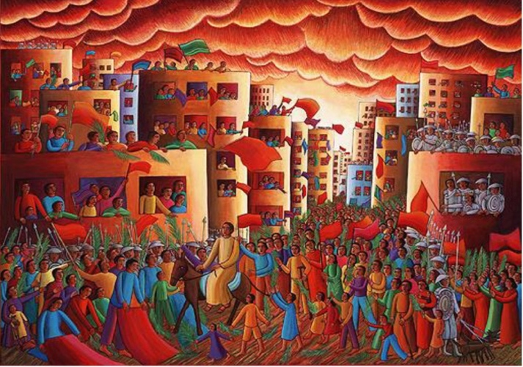
Blessed?
Blessed?
Absolutely!
Absolutely!
Anyone who can draw in this sort of crowd
This sort of adulation
This sort of fervour
Hey, they must be blessed!

A rock star welcome!
Jesus, ride on!
Created by John August Swanson.
Crowds out in their multitudes
from every crevice in the Jerusalem woodwork
… stonework
to meet you
to greet you
to praise you
to worship you
to check you out

to check out this oddity
this living, breathing, polarising
Captivating conundrum
that is you
the one who rides into town
as Prince of Peace
Not warrior of war and might …
as one who mounts a donkey
as one I’ve heard Peter proclaims
as the Christ, the Lord, the Messiah
as the Son of the living God
as the one … as the one
who soon will be mounted to a cross

as one who says
turn the other cheek
as one who offers
a new commandment to love
as one who rebuts the establishment’s cries
for the cheering to cease
as one who in the middle of this jubilant mayhem
cries out: “I tell you, if they keep quiet,
the stones under your feet will cry out!”

as one who says the last and the least and the lost
will come first
first at the table
first in your new kingdom
of grace, welcome,
hope and life
salvation
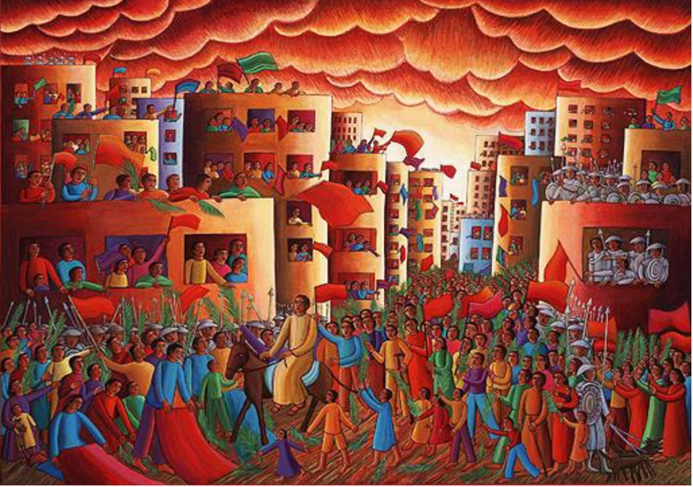
as one who not only talks about God
but who is God
who not only calls us to holiness
but is holiness
who not only calls us to repentance
but is repentance
who is forgiveness

Jesus, ride on!

Jesus, God
we’ve taken in your teaching
we’ve marvelled at your miracles
we’ve wowed at your wisdom
But how could all this be?

I’m waving my palm branches
My red cloak is laid out as you come by
Red cloaks, blue cloaks, green cloaks
They’re all being waved.
Green – for life and peace
Blue – for something deep in the soul … the heart
Red – well, raising a red flag means
Sit up and take notice
Something’s happening here
Something unusual
maybe even not right
Yes, red flag for me.
This is no ordinary parade
No ordinary welcome.

Forget the soldiers, the scoffers, the skeptics
I’ve heard what they think of you ...
nothing but treachery
nothing but blasphemy
nothing but insurrection
nothing but elimination

Jesus
I can only tell my own story
We can only tell our own stories
When it was all hopeless
You offered my hope

When I was afraid
You offered your presence
When I felt forgotten
You brought me in
Offered welcome
Life in abundance
Life overflowing.

Is that what everyone around me
hollers about?
The latest Messiah
to get us out of our deep mess?
I’ve heard you’ll be tried
I’ve heard you’ll be betrayed
I’ve heard you’ll be ridiculed something shocking
I’ve heard - to be blunt
– they want to get rid of you
once and for all.

But that’s not all I’ve heard
I’ve heard there’s more to you
There always seems to be more to you.
That you promise a response
Like only God can offer
There always seems to be more to you.
You say the taints and torture
A deathly torture, no less
It won’t be the end
No way.
will be just the beginning.

So Jesus
Ride on
You Prince of Peace
Ride on
You healer of hearts

Ride on
You Son of God
… to your future
Not for yourself
No!
To our future
The future of all creation
Forever

So Jesus
bring in your kingdom some more
Go to your cross
Go beyond
Save us
Love us
Free us!
Ride on, Jesus!

Ride on
Blessed
Obedient,
faithful one
Saviour
Befriender
Welcomer
Redeemer
Messiah
Christ
Lord

David MacGregor
Ash Wednesday, 2020

