Blessed
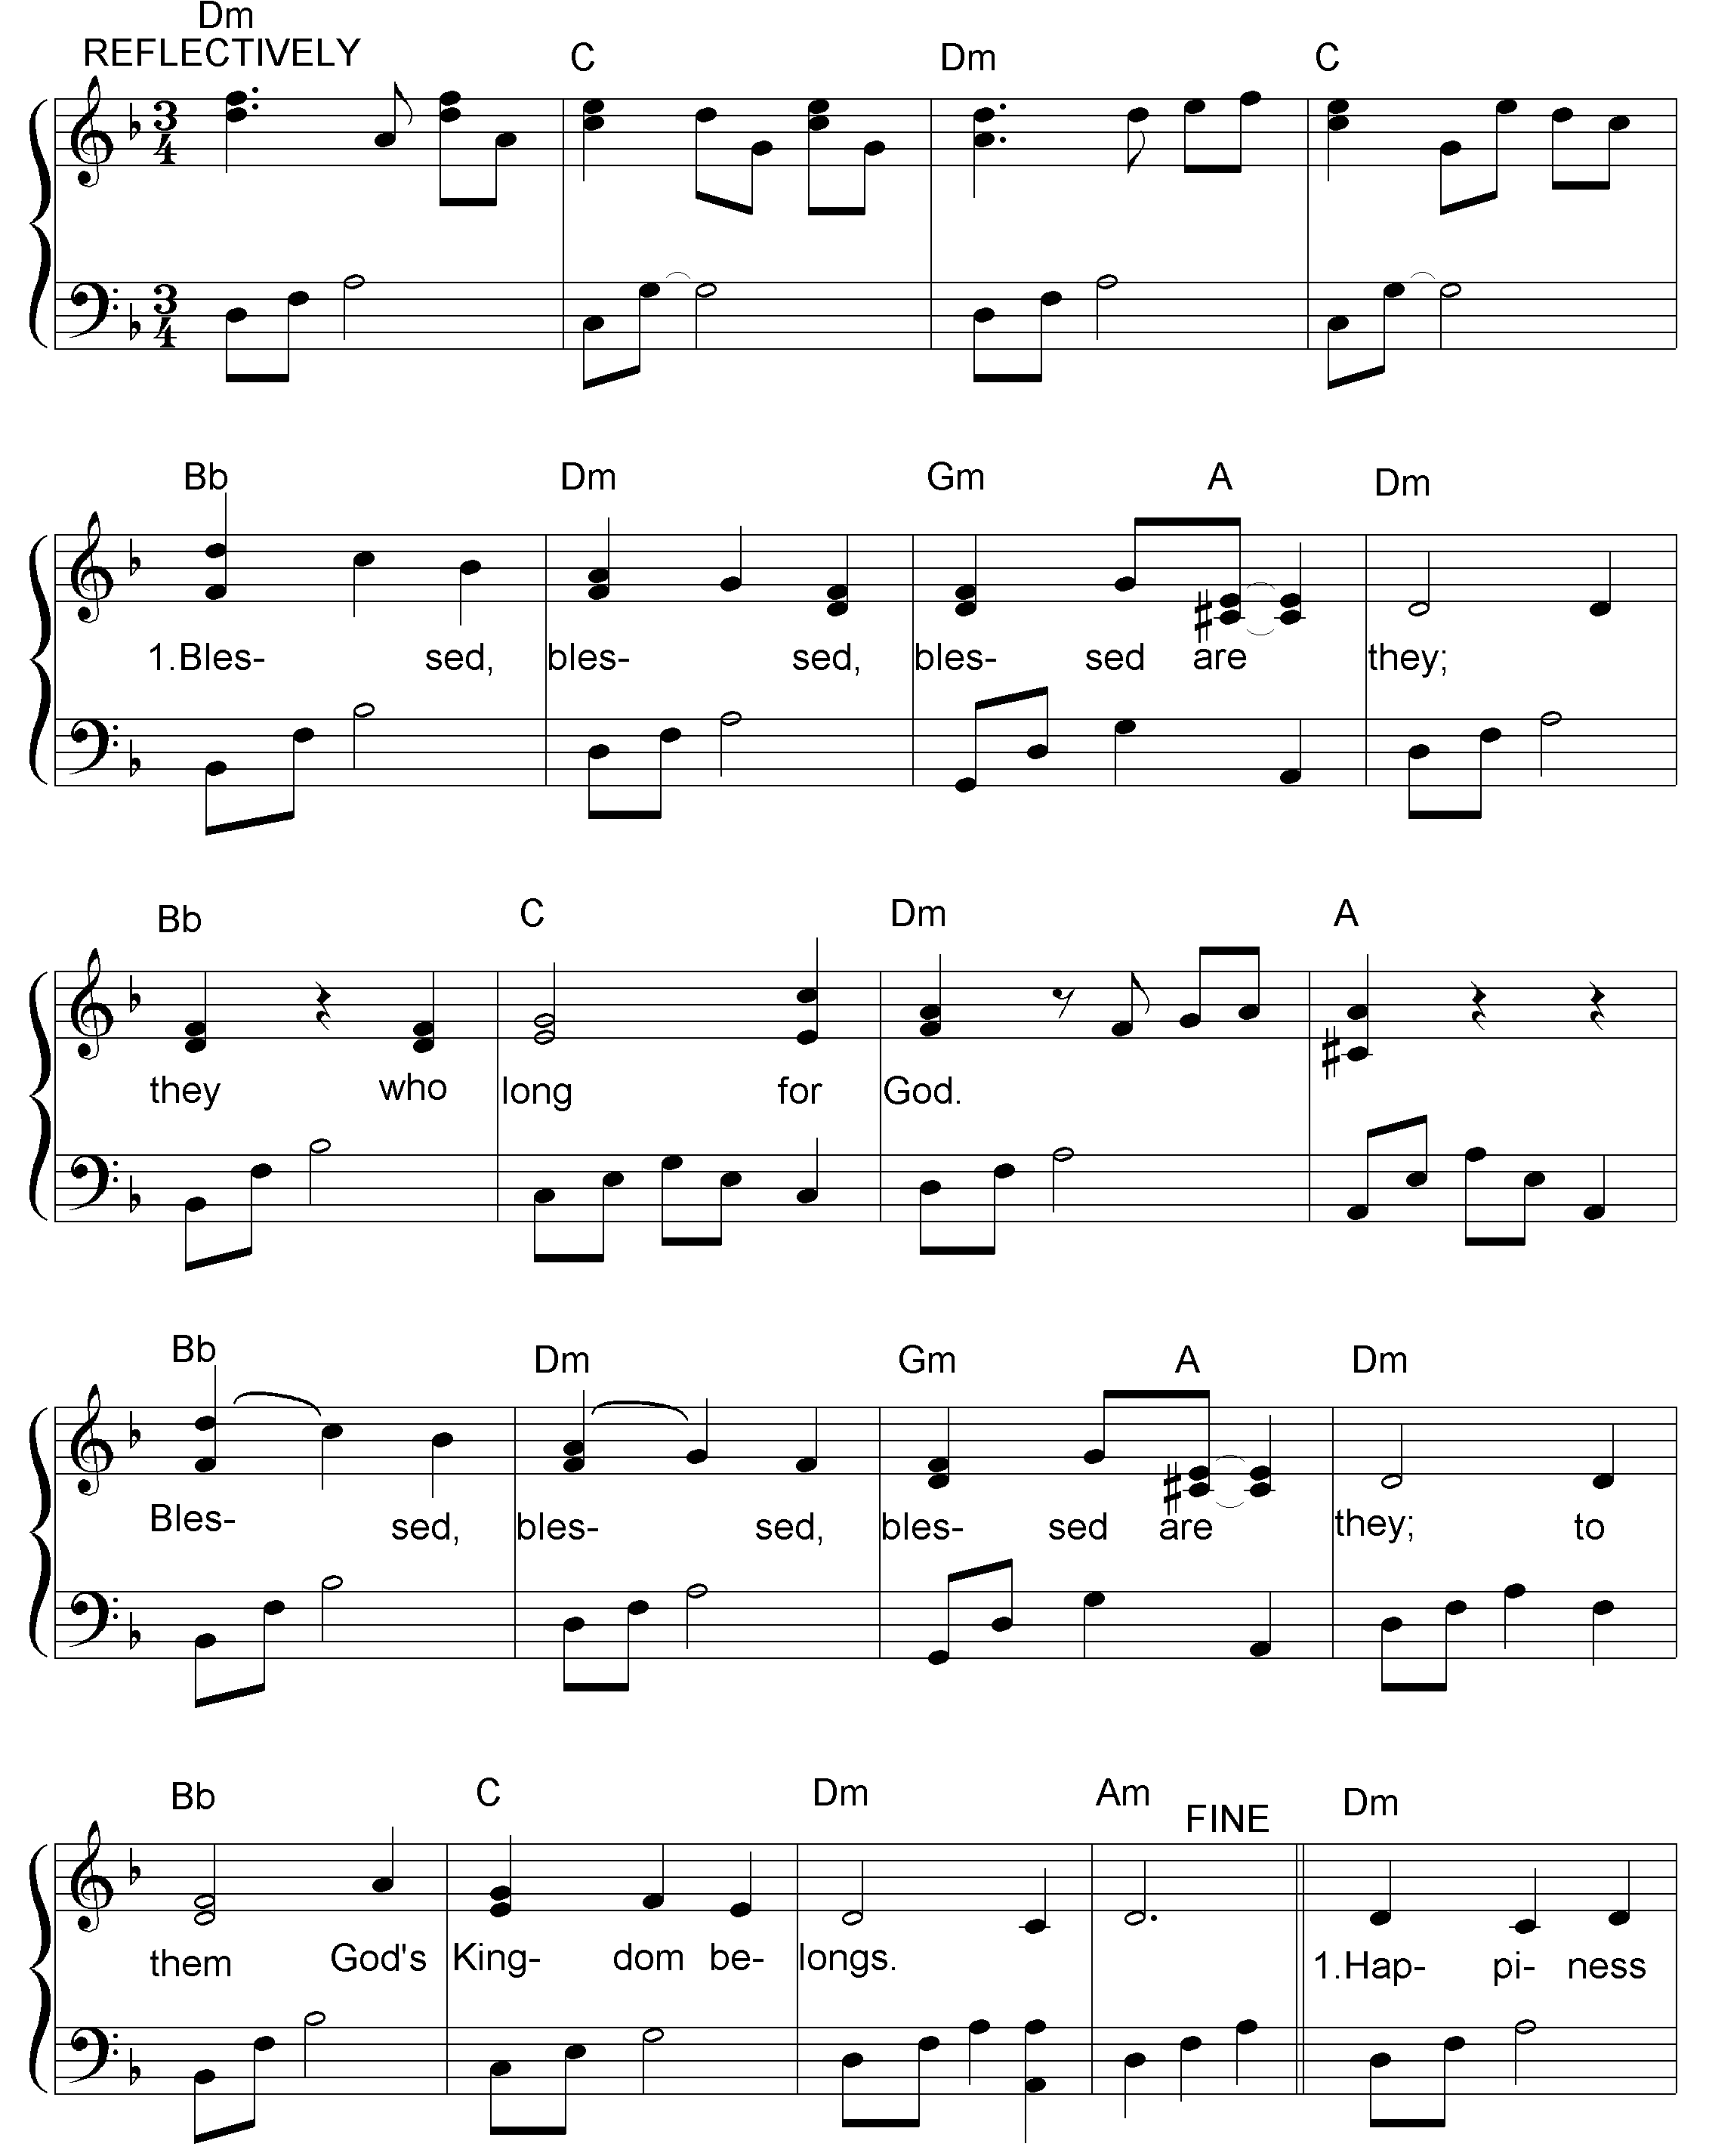



2. Happiness comes to they who walk
humbly with their God.
To they who share compassion's heart,
the grace of God will be shown.

3. Happiness to the pure in heart,
to those who suffer long;
faithful to God, who work for peace.
God calls each one his child.

© David MacGregor 1993

